CSS is the language we use to style a Web page.
- CSS stands for Cascading Style Sheets
- CSS describes how HTML elements are to be displayed on screen, paper, or in other media
- CSS saves a lot of work. It can control the layout of multiple web pages all at once
- External stylesheets are stored in CSS files
CSS Syntax (Cú pháp)
Selector { declaration (property: value); declaration( property: value)}

CSS Selectors
SELECTORS
We can divide CSS selectors into five categories:
- Simple selectors (select elements based on name, id, class)
- Combinator selectors (select elements based on a specific relationship between them)
- Pseudo-class selectors (select elements based on a certain state)
- Pseudo-elements selectors (select and style a part of an element)
- Attribute selectors (select elements based on an attribute or attribute value)
Theo ID (Có dấu thăng)
#p {
text-align: center;
color: red;
}
id là p, thường những id nào trong html sẽ bị thay đổi theo
Theo class
In this example all HTML elements with class="center" will be red and center-aligned:
.center {
text-align: center;
color: red;
}
In this example only <p> elements with class="center" will be red and center-aligned:
p.center {
text-align: center;
color: red;
}
In this example the <p> element will be styled according to class="center" and to class="large":
<p class="center large">This paragraph refers to two classes.</p>
GROUPING SELECTORS
Nếcu các elements chung style thì
h1, h2, p {
text-align: center;
color: red;
}

Selector | Example | Example description
#id | #firstname | Selects the element with id="firstname"
.class | .intro | Selects all elements with class="intro"
* | * | Selects all elements
element | p | Selects all <p> elements
element,element,.. | div, p | Selects all <div> elements and all <p> elements
CSS How to
External CSS
Each HTML page must include a reference to the external style sheet file inside the <link> element, inside the head section.
!DOCTYPE html>
<html>
<head>
<link rel="stylesheet" href="mystyle.css">
</head>
<body>

<h1>This is a heading</h1>
<p>This is a paragraph.</p>

</body>
</html>
Inline CSS
An inline style may be used to apply a unique style for a single element.
To use inline styles, add the style attribute to the relevant element. The style attribute can contain any CSS property.
<!DOCTYPE html>
<html>
<body>

<h1 style="color:blue;text-align:center;">This is a heading</h1>
<p style="color:red;">This is a paragraph.</p>

</body>
</html>
Multiple Style Sheets
Nếu external style sheet
h1 {
color: navy;
}
Mà internal style sheet
h1 {
color: orange;
}
Tuỳ thuộc cái nào đứng trước=))) internal trc thì cam, external trước thì navy

CSS COLORS
In CSS, colors are specified by using a predefined color name, or with a RGB, HEX, HSL, RGBA, HSLA value.
CSS Color Names
In CSS, a color can be specified by using a predefined color name:
-> link: https://www.w3schools.com/colors/colors_names.asp
CSS Background Color
<h1 style="background-color:DodgerBlue;">Hello World</h1>
<p style="background-color:Tomato;">Lorem ipsum...</p>
Result:
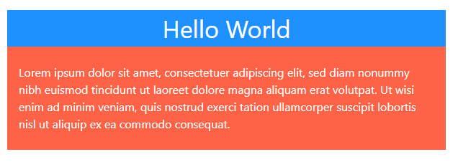
CSS Text Color
<h1 style="color:Tomato;">Hello World</h1>
<p style="color:DodgerBlue;">Lorem ipsum...</p>
<p style="color:MediumSeaGreen;">Ut wisi enim...</p>
Result:
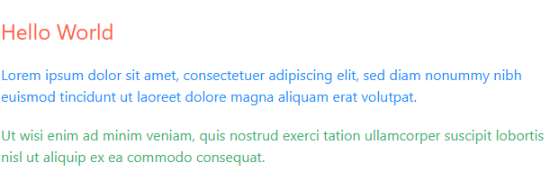
CSS Border Color
<h1 style="border:2px solid Tomato;">Hello World</h1>
<h1 style="border:2px solid DodgerBlue;">Hello World</h1>
<h1 style="border:2px solid Violet;">Hello World</h1>
Result:
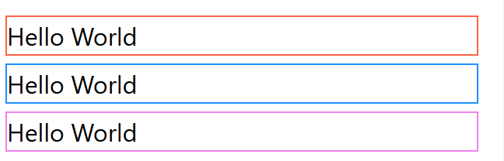
CSS Color Values
In CSS, colors can also be specified using RGB values, HEX values, HSL values, RGBA values, and HSLA values:
VD:
<h1 style="background-color:rgb(255, 99, 71);">...</h1>
<h1 style="background-color:#ff6347;">...</h1>
<h1 style="background-color:hsl(9, 100%, 64%);">...</h1>
<h1 style="background-color:rgba(255, 99, 71, 0.5);">...</h1>
<h1 style="background-color:hsla(9, 100%, 64%, 0.5);">...</h1>
RGB Value
An RGB color value represents RED, GREEN, and BLUE light sources.
In CSS, a color can be specified as an RGB value, using this formula:
rgb(red, green, blue)
Each parameter (red, green, and blue) defines the intensity of the color between 0 and 255.
RGBA Value
RGBA color values are an extension of RGB color values with an alpha channel - which specifies the opacity for a color.
An RGBA color value is specified with:
rgba(red, green, blue, alpha)
HEX Colors
A hexadecimal color is specified with: #RRGGBB.
In CSS, a color can be specified using a hexadecimal value in the form:
#rrggbb
Where rr (red), gg (green) and bb (blue) are hexadecimal values between 00 and ff (same as decimal 0-255).
For example, #ff0000 is displayed as red, because red is set to its highest value (ff) and the others are set to the lowest value (00).
To display black, set all values to 00, like this: #000000.
To display white, set all values to ff, like this: #ffffff.
3 digit HEX Value
Sometimes you will see a 3-digit hex code in the CSS source.
The 3-digit hex code is a shorthand for some 6-digit hex codes.
The 3-digit hex code has the following form:
#rgb
Where r, g, and b represent the red, green, and blue components with values between 0 and f.
The 3-digit hex code can only be used when both the values (RR, GG, and BB) are the same for each component. So, if we have #ff00cc, it can be written like this: #f0c.
HSL Value
HSL stands for hue, saturation, and lightness.
In CSS, a color can be specified using hue, saturation, and lightness (HSL) in the form:
hsl(hue, saturation, lightness)
Hue is a degree on the color wheel (from 0 to 360):
- 0 (or 360) is red
- 120 is green
- 240 is blue
Saturation is a percentage value: 0% means a shade of gray, and 100% is the full color.
Lightness is also a percentage; 0% is black, 50% is neither light or dark, 100% is white.

Saturation
Saturation can be described as the intensity of a color.
100% is pure color, no shades of gray.
50% is 50% gray, but you can still see the color.
0% is completely gray; you can no longer see the color.

Lightness
The lightness of a color can be described as how much light you want to give the color, where 0% means no light (black), 50% means 50% light (neither dark nor light) and 100% means full lightness (white).

Shades of Gray
Shades of gray are often defined by setting the hue and saturation to 0, and adjust the lightness from 0% to 100% to get darker/lighter shades:
HSLA Value
HSLA color values are an extension of HSL color values with an alpha channel - which specifies the opacity for a color.
An HSLA color value is specified with:
hsla(hue, saturation, lightness, alpha)

CSS BACKGROUND-COLOR
Có 6 loại background colors:
- background-color
- background-image
- background-repeat
- background-attachment
- background-position
- Background (shorthand property)
CSS background-color
The background-color property specifies the background color of an element.
body {
background-color: lightblue;
}
With CSS, a color is most often specified by:
- a valid color name - like "red"
- a HEX value - like "#ff0000"
- an RGB value - like "rgb(255,0,0)"
Opacity/Transparency
The opacity property specifies the opacity/transparency of an element. It can take a value from 0.0 - 1.0. The lower value, the more transparent:
ex:
div {
background-color: green;
opacity: 0.3;
}
If you do not want to apply opacity to child elements, use RGBA color values. The following example sets the opacity for the background color and not the text:
Transparency using RGBA
An RGBA color value is specified with: rgba(red, green, blue, alpha). The alpha parameter is a number between 0.0 (fully transparent) and 1.0 (fully opaque).
div {
background: rgba(0, 128, 0, 0.3) /* Green background with 30% opacity */
}

Background Image
property specifies an image to use as the background of an element.
body {
background-image: url("paper.gif");
}
Background Repeat
The background-repeat property sets if/how a background image will be repeated.
Các giá trị phổ biến
- repeat (Mặc định): Ảnh lặp lại cả ngang và dọc.
- repeat-x: Chỉ lặp lại theo chiều ngang. (Rất hữu ích khi bạn dùng một tấm ảnh dải màu gradient mỏng để làm nền phía trên đầu trang).
- repeat-y: Chỉ lặp lại theo chiều dọc.
- no-repeat: Ảnh chỉ xuất hiện 1 lần duy nhất, không lặp lại. Đây là giá trị hay được dùng nhất khi làm banner hoặc logo nền.
background-position: tại dùng no-repeat, tấm hình mặc định ở trái -> position giúp chuyển ra chỗ khác.
Background-attachment
Specifies whether the background image should scroll or be fixed (will not scroll with the rest of the page). (fixed / scroll)
Background-shorthand
Specify all the background properties in one single property -> called a shorthand property.
Thay vì phải code:
body {
background-color: #ffffff;
background-image: url("img_tree.png");
background-repeat: no-repeat;
background-position: right top;
}
Ta ghi:
body {
background: #ffffff url("img_tree.png") no-repeat right top;
}
Có những thuộc tính sau:
- background-color
- background-image
- background-position
- background-size
- background-repeat
- background-attachment
- background-origin
- background-clip
Example:
body {
background-color: lightblue;
background-image: url('img_tree.png');
/* background-image */
/* background-repeat */
background-repeat: no-repeat;
background-position: right top;
/* background-position */
}

BORDERS
Allows you to specify the style, width, and color of an element's border.
CSS Border Style
The border-style property specifies what kind of border to display.
The following values are allowed:
- dotted - Defines a dotted border
- dashed - Defines a dashed border
- solid - Defines a solid border
- double - Defines a double border
- groove - Defines a 3D grooved border. The effect depends on the border-color value
- ridge - Defines a 3D ridged border. The effect depends on the border-color value
- inset - Defines a 3D inset border. The effect depends on the border-color value
- outset - Defines a 3D outset border. The effect depends on the border-color value
- none - Defines no border
- hidden - Defines a hidden border
The border-style property can have from one to four values (for the top border, right border, bottom border, and the left border).
Ví dụ:

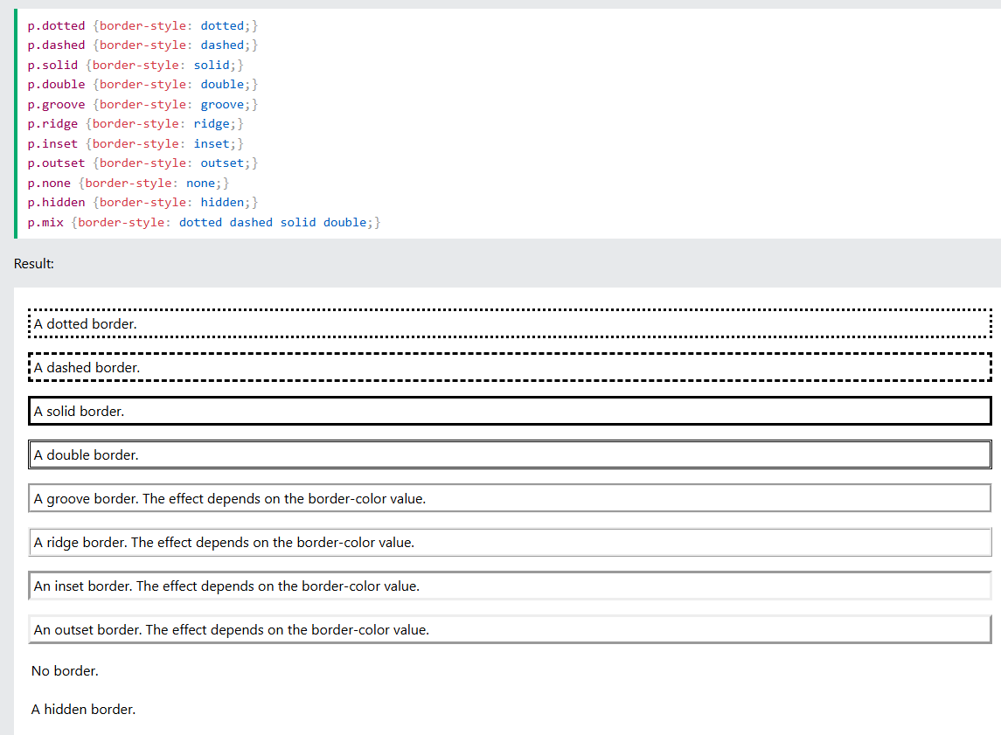

CSS Border Width
The border-width property specifies the width of the four borders.
Can be set as a specific size (in px, pt, cm, em, etc) or by using one of the three pre-defined values: thin, medium, or thick:
The border-width property can have from one to four values (for the top border, right border, bottom border, and the left border.
Ex:
p.three {
border-style: solid;
border-width: 25px 10px 4px 35px; /* 25px top, 10px right, 4px bottom and 35px left */
}
CSS Border Color
The border-color property is used to set the color of the four borders.
The color can be set by:
- name - specify a color name, like "red"
- HEX - specify a HEX value, like "#ff0000"
- RGB - specify a RGB value, like "rgb(255,0,0)"
- HSL - specify a HSL value, like "hsl(0, 100%, 50%)"
- transparent
CSS Border Sides
In CSS, there are also properties for specifying each of the borders (top, right, bottom, and left):
- border-top-style
- border-right-style
- border-bottom-style
- border-left-style
Example:
p {
border-top-style: dotted;
border-right-style: solid;
border-bottom-style: dotted;
border-left-style: solid;
}
Results:
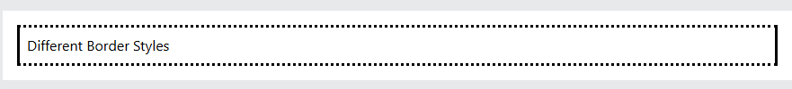
Border Shorthand
The border property is a shorthand property for the following 3 individual border properties:
- border-width
- border-style (required)
- border-color
p{
border-left: 5px solid red;
};
Rounded Borders
border-radius property is used to add rounded borders to an element.
ex: border-radius: 5px;

CSS Margins
Properties are used to create space around elements, outside of any defined borders. Tức là lề được dùng để tạo ra khoảng không gian xung quanh bên ngoài một phần tử.
Margin - Individual Sides
CSS has properties for specifying the margin for each side of an element:
- margin-top - sets the top margin of an element
- margin-right - sets the right margin of an element
- margin-bottom - sets the bottom margin of an element
- margin-left - sets the left margin of an element
All the margin properties can have the following values:
- auto - the browser calculates the margin
- length - specifies a margin in px, pt, cm, etc.
- % - specifies a margin in % of the width of the containing element
- inherit - specifies that the margin should be inherited from the parent element
Example:
p {
margin-top: 100px;
margin-bottom: 100px;
margin-right: 150px;
margin-left: 80px;
}
If the margin property has two values:
- margin: 25px 50px;
  - top and bottom margins are 25px
  - right and left margins are 50px
If the margin property has one value:
- margin: 25px;
  - all four margins are 25px
The auto Value
You can set the margin property to auto to horizontally center the element within its container.
The element will then take up the specified width, and the remaining space will be split equally between the left and right margins.
Ex:
div {
width: 300px;
margin: auto;
border: 1px solid red;
}
The inherit Value
You can set the margin property to inherit to let the margin be inherited from the parent element.
This example lets the left margin of the <p class="ex1"> element be inherited from the parent element (<div>):
ORDER: top, right, bottom, left.
Example: margin: 10px 20px 30px 40px;
MARGIN COLLAPSE (Hiệp ứng gộp lề)
Margin collapse is when two margins collapse into a single margin.
Top and bottom margins of elements are sometimes collapsed into a single margin that is equal to the largest of the two margins.
Giả sử bạn có hai khối (div) nằm chồng lên nhau:
- Thằng bên trên có margin-bottom: 50px;
- Thằng bên dưới có margin-top: 20px;
Theo logic thông thường, khoảng cách giữa 2 thằng phải là 50px + 20px = 70px. Nhưng thực tế, trình duyệt chỉ hiển thị khoảng cách là 50px (vì 50 lớn hơn 20).
Note: Margin collapse only happens with top and bottom margins! Not left and right margins!

PADDING
Generate space around an element's content, inside of any defined borders. Dễ hiểu là khoảng cách giữa phần tử bên trong border đến border.
CSS has properties for specifying the padding for each side of an element:
- padding-top - sets the top padding of an element
- padding-right - sets the right padding of an element
- padding-bottom - sets the bottom padding of an element
- padding-left - sets the left padding of an element
All the padding properties can have the following values:
- length - specifies a padding in px, pt, cm, etc.
- % - specifies a padding in % of the width of the containing element
- inherit - specifies that the padding should be inherited from the parent element
Ex:
div {
padding-top: 50px;
padding-right: 30px;
padding-bottom: 50px;
padding-left: 80px;
}
Padding - Shorthand Property
The padding property is a shorthand property for the following individual padding properties:
- padding-top
- padding-right
- padding-bottom
- padding-left
Ex:
- padding: 25px 50px 75px 100px;
  - top padding is 25px
  - right padding is 50px
  - bottom padding is 75px
  - left padding is 100px
Trường hợp 4 gtri (mặc định): top, right, bottom, left.
Trường hợp 3 giá trị: top, right left, bottom
Trường hợp 2 giá trị: top bottom, right left
Trường hợp 1 giá trị: cả 4
Padding box-sizing
The CSS width property specifies the width of the element's content area. The content area is the portion inside the padding, border, and margin of an element (the box model).

